- Private sector regular pay growth came in slightly lower than the Bank of England's expectations in March, keeping a June rate cut in play. But next month's labour market release will likely present a more formidable obstacle, with the wage data set to incorporate the impact of April's large rise in the national living wage.
- Speeches from MPC members Huw Pill and Megan Greene confirmed the importance of the pay data in determining the timing of the first rate cut. But both gave little away about their voting intentions and were vague on the criteria against which they would judge incoming data.
The minutes of last week's Monetary Policy Committee meeting had shone the spotlight on upcoming labour market and inflation releases, suggesting these data points would be crucial in determining the timing of the first interest rate cut. The first of those releases was published this week and appeared to keep the MPC on track to cut rates in June.
Private sector regular pay growth – the Bank of England's favoured measure – edged down to 5.9% in the three months to March. Projections by BoE staff have acted as an informal benchmark against which we can measure incoming data that matters to the MPC. As we noted last week, in May's Monetary Policy Report, BoE staff had raised their projection for private sector regular pay growth, thus reducing the scope for upside surprises to derail a potential rate cut. And March's outturn duly came in below the new forecast, but above the previous projection (Chart 1). So the first hurdle to a rate cut has been cleared.
In reality, this was probably the easiest of the four barriers that must be negotiated before June's MPC meeting. The second comes next week, when the April inflation data will show the impact on core inflation of the annual increases for index-linked contracts and regulated prices. On pay, next month's labour market release will likely present a more formidable obstacle given it will include the impact of April's near-10% rise in the national living wage.
Chart 1: Pay growth came in slightly lower than the BoE's new forecast
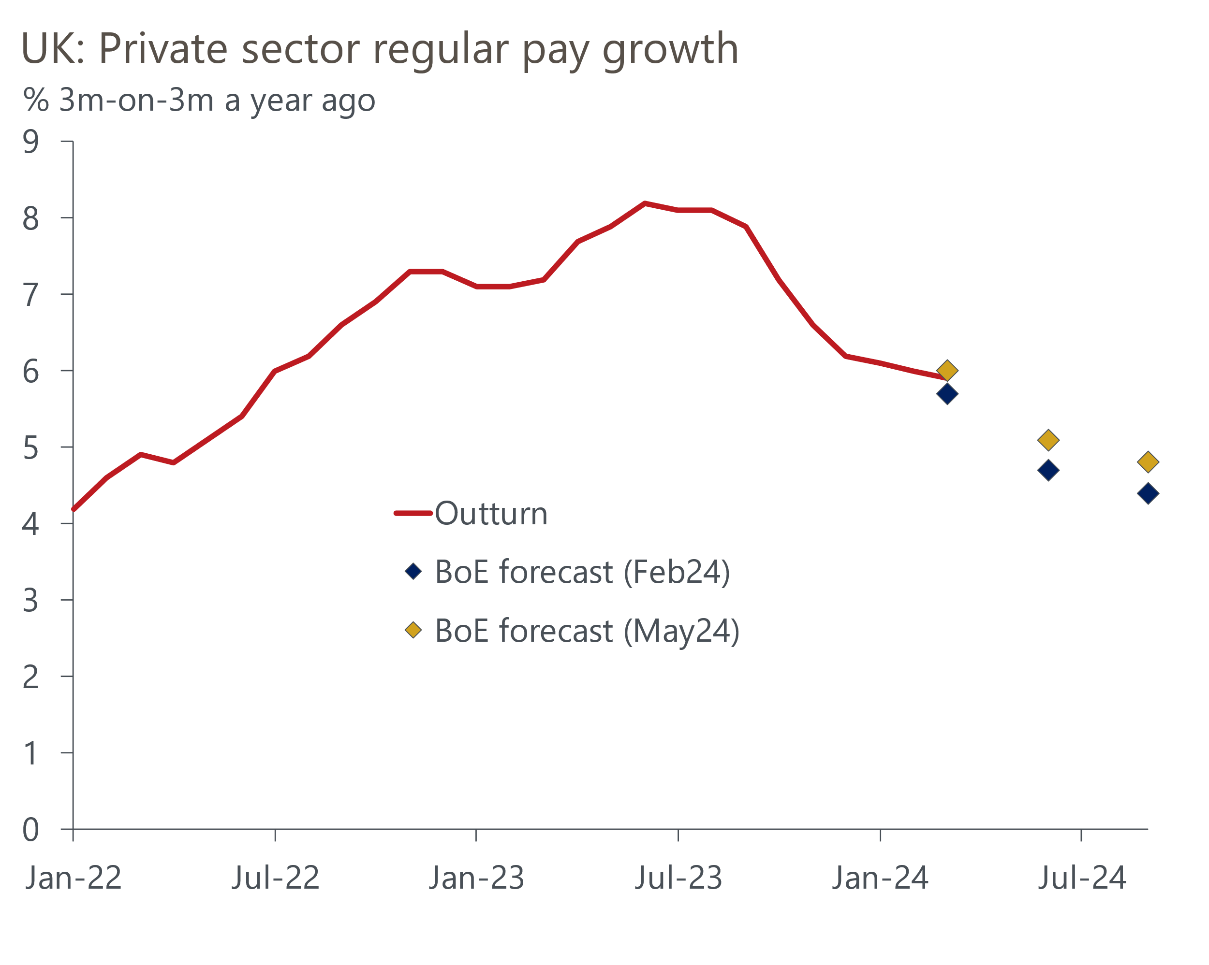
Sources: Haver Analytics, Bank of England Monetary Policy Report

Timelier HMRC Real Time Information data offered conflicting signals on likely movements in the average weekly earnings series next month. The headline HMRC median pay series jumped to 6.9% y/y in April from 6.4% in March, the highest rate in eight months (Chart 2). But the ONS also presents another version of the data, where annual pay growth is calculated for all of the individuals in the HMRC dataset and then the median is selected. So this measure only covers those people who have been employed in both the current month and the same month of the previous year. This measure has tended to be less volatile than the headline HMRC series and of late it has tracked the equivalent average weekly earnings series more closely. This series showed median pay growth slowing to 6.1% in April from 6.4% in March.
Chart 2: Timelier HMRC data offers conflicting signals on the strength of pay growth in April
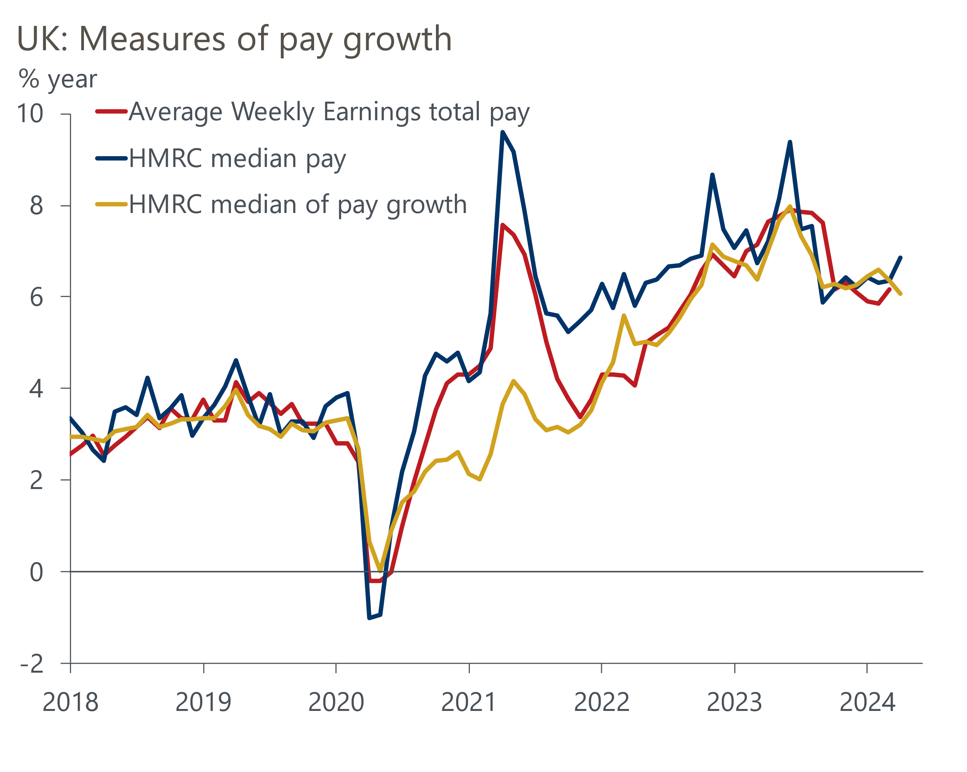
Sources: Haver Analytics, ONS
Elsewhere in the labour market release, there was further evidence of loosening labour market conditions. The ongoing volatility caused by low response rates means we place little store on the Labour Force Survey data, which showed the unemployment rate edging up to 4.3%. A range of other data also suggest conditions are continuing to loosen. Most notably, vacancies continued to edge down, while HMRC's count of payrolled employees showed a large m/m fall in April. Loosening labour market conditions should add to the downward pressures on pay growth over the coming months.
Two MPC members made speeches this week but left us none the wiser about their voting intentions. BoE Chief Economist Huw Pill gave a presentation for ICAEW, but unusually the speech was not made available on the BoE website. Reports suggested that Pill said, "it's not unreasonable to believe that through the summer we will begin to see enough confidence in the decline in persistence that Bank Rate will come into consideration." But he also cautioned that the labour market remains tight by historical standards, and of the four internal members currently voting to hold rates, Pill appears the furthest from voting for a cut.
External member Megan Greene made a speech to Make UK. She argued there were two puzzles in the labour market. First, that unemployment has stayed low despite weak output. Second, that wage growth has remained strong despite inflation expectations easing and the labour market loosening. Greene argued that excess labour hoarding can partly explain both puzzles. This certainly looked like a strong explanation of the low unemployment rate 18 months ago, when reports of skills shortages were rife. But it looks much less convincing now. Up until recently, output had barely grown for two years, while firms have faced a barrage of cost pressures. Under those conditions, both firms' incentive and ability to hoard labour have diminished. Indeed, a range of indicators suggest labour market conditions have loosened markedly.
Overall, Greene's tone was less hawkish than her previous comments. She hinted she was part of the MPC consensus view that the April pay data will be key, albeit with the rider that evidence of passthrough of wage costs to prices will also be important.
On balance, a June rate cut remains in play after this week's data and speeches. But next week's inflation data should offer a stronger steer.

The week ahead
The April inflation data will be particularly important given it will include the once-a-year price increases for many index-linked contracts and regulated prices. Large increases for these goods and services last April baked in high inflation for these categories for the following year. This year's increases are likely to be smaller, but still higher than 'normal' increases. The 12% fall in the energy price cap will also hit the inflation index in April. A larger drag from energy and a falling contribution from core inflation means we expect CPI inflation to fall to 2.2% in April.
Public sector net borrowing has been consistently falling on a y/y basis in recent months. That borrowing was boosted in early-2023 by energy support payments is part of the story, and with those payments having finished in March 2023, this factor will no longer weigh on the y/y comparison from April. But with lower inflation continuing to drag on debt interest costs, and revenues continuing to be supported by strong wage growth, we still expect to see a chunky y/y drop in borrowing. We expect public sector net borrowing to have been £18bn in April.
April's S&P Global surveys reported the strongest reading for the composite PMI for 11 months, following a strong pickup in services activity. We think there's a good chance of a further gain in May's flash survey, with lower inflation continuing to boost demand, particularly in the services sector. We look for the composite PMI to rise to 54.3.
Though retail sales were flat in March, this masked significant variation across the sub-sectors. The earlier-than-normal Easter is likely to have been a factor in this variation, and history suggests that early Easters tend to be associated with softer outturns in March and stronger performances in April. Factoring in this evidence, and the scope for rebounds in the food and non-food sectors, we expect retail sales to have risen by 0.3% m/m in April.
Table 1: Week ahead calendar
Date | Events | Period | Measure | Unit | Previous | Forecast
May 22 | CPI inflation | Apr | m/m | % | 0.6 | 0.2
May 22 | CPI inflation | Apr | y/y | % | 3.2 | 2.2
May 22 | RPI inflation | Apr | m/m | % | 0.5 | 0.8
May 22 | RPI inflation | Apr | y/y | % | 4.3 | 3.5
May 22 | Producer input prices | Apr | m/m | % | -0.1 | -0.1
May 22 | Producer input prices | Apr | y/y | % | -2.5 | -2.2
May 22 | Producer output prices | Apr | m/m | % | 0.2 | 0.2
May 22 | Producer output prices | Apr | y/y | % | 0.6 | 1.0
May 22 | Public finances | Apr | PSNB ex | £bn | 11.9 | 18.0
May 22 | Land Registry house prices | Mar | y/y | % | -0.2 | 0.3
May 23 | S&P Global manufacturing | May | PMI | % bal | 49.1 | 49.5
May 23 | S&P Global services | May | PMI | % bal | 55.0 | 55.2
May 23 | S&P Global composite | May | PMI | % bal | 54.1 | 54.3
May 24 | Retail sales inc fuel | Apr | m/m | % | 0.0 | 0.3
May 24 | Retail sales inc fuel | Apr | y/y | % | 0.8 | 0.5
Source: Oxford Economics

Key forecasts
Table 2: UK forecast overview
(Annual percentage changes unless specified)
 | 2022 | 2023 | 2024 | 2025 | 2026 | 2027
GDP | 4.3 | 0.1 | 0.9 | 2.0 | 1.9 | 1.6
Private consumption | 4.8 | 0.2 | 0.7 | 2.6 | 2.2 | 1.6
Fixed investment | 8.0 | 2.2 | -0.5 | 0.8 | 2.7 | 2.1
Government consumption | 2.3 | 0.5 | 3.4 | 2.8 | 1.6 | 1.5
Exports of goods and services | 9.0 | -0.5 | -0.9 | 2.7 | 2.3 | 1.7
Imports of goods and services | 14.6 | -1.5 | 0.2 | 4.7 | 2.9 | 1.9
Industrial Production | -3.5 | -0.4 | 0.3 | 0.9 | 1.5 | 1.2
Consumer prices | 9.1 | 7.3 | 2.3 | 2.2 | 2.3 | 2.2
Unemployment rate (%) | 3.9 | 4.0 | 4.3 | 4.0 | 3.8 | 3.8
Current a/c balance (% of GDP) | -3.1 | -3.3 | -2.7 | -3.1 | -3.2 | -3.1
Government balance (% of GDP) | 4.4 | 5.0 | 3.6 | 3.1 | 2.3 | 1.5
Cen. bank policy rate (%, EOP) | 3.50 | 5.25 | 4.50 | 3.50 | 2.50 | 2.00
10yr govt. bond yield (%, EOP) | 3.67 | 3.54 | 3.92 | 3.53 | 3.07 | 2.85
Exchange rate (US$ per £, EOP) | 1.20 | 1.27 | 1.26 | 1.27 | 1.30 | 1.32
Exchange rate (euro per £, EOP) | 1.13 | 1.15 | 1.17 | 1.17 | 1.17 | 1.16
Source: Oxford Economics
Table 3: Quarterly forecasts for the UK
 | 2024 |  |  |  | 2025
 | Q1 | Q2 | Q3 | Q4 | Q1 | Q2 | Q3 | Q4
GDP (% year) | 0.2 | 0.5 | 1.0 | 1.9 | 1.7 | 2.0 | 2.1 | 2.2
CPI inflation (% year) | 3.5 | 1.9 | 1.8 | 2.1 | 2.0 | 2.0 | 2.3 | 2.3
Bank Rate (%, EOP) | 5.25 | 5.00 | 4.75 | 4.50 | 4.25 | 4.00 | 3.75 | 3.50
10yr gilt yield (%, EOP) | 3.95 | 4.10 | 3.99 | 3.92 | 3.83 | 3.74 | 3.64 | 3.53
US$ per £ (EOP) | 1.26 | 1.25 | 1.25 | 1.26 | 1.26 | 1.26 | 1.27 | 1.27
Euro per £ (EOP) | 1.17 | 1.17 | 1.17 | 1.17 | 1.17 | 1.17 | 1.17 | 1.17
Source: Oxford Economics

Latest Country Economic Forecast:
May 15, 2024

Recent publications

Data Insights
Pay data offers something for doves and hawks alike
Strong March delivers a big upside surprise for GDP in Q1
April's services PMI suggests Q2 started on a strong footing
April's PMI pointed to a renewed fall in manufacturing activity
Higher interest rates temper recovery in mortgage demand

Research Briefings
How quickly are indirect effects on core inflation fading?
Dovish MPC signals a summer rate cut is likely
MPC preview – Edging closer to rate cuts
Nowcast shows wage growth slowing sharply
What the Bernanke review says about the state of forecasting

Contacts

Oxford Economics' UK team
- Andrew Goodwin - Chief UK Economist - agoodwin@oxfordeconomics.com
- Edward Allenby - UK Economist - eallenby@oxfordeconomics.com

